How to copy data from 1 adls to another

1. Create adls storage account create container create directory upload files
2. Create data factory
3. Create pipline by going to author in datafactoy as previously given in previous word files

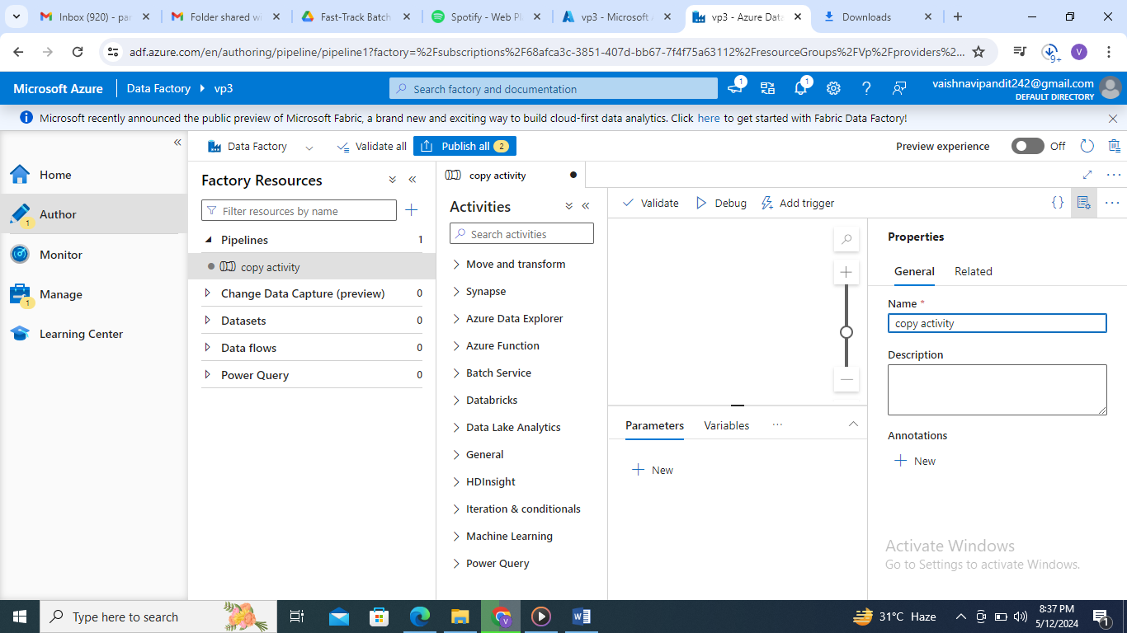

1. Now go to move and transform

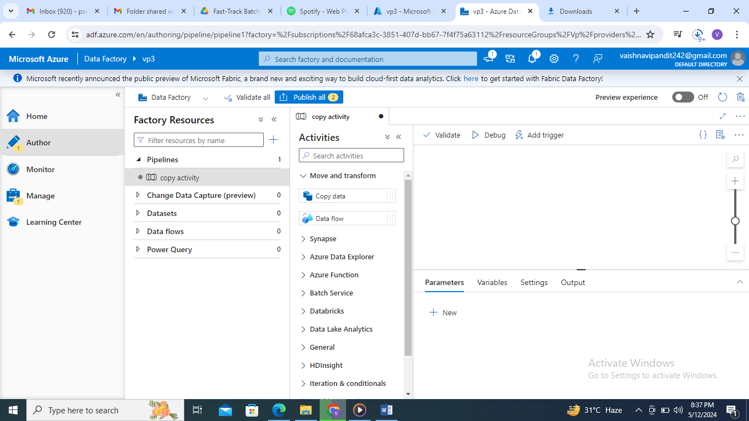

1. now drag and drop copy data

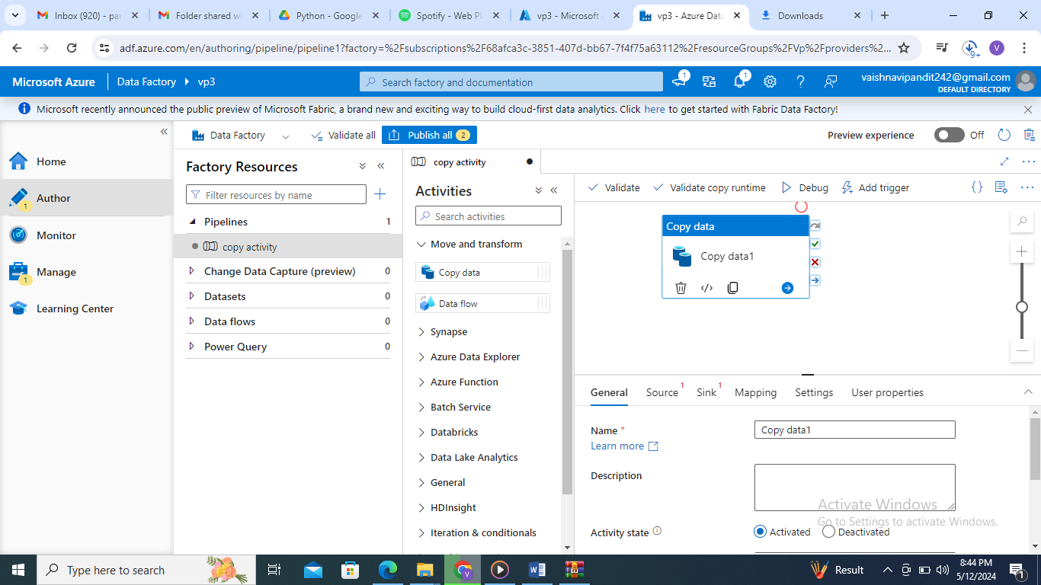

1. now create a linked service

go to manage->linked service

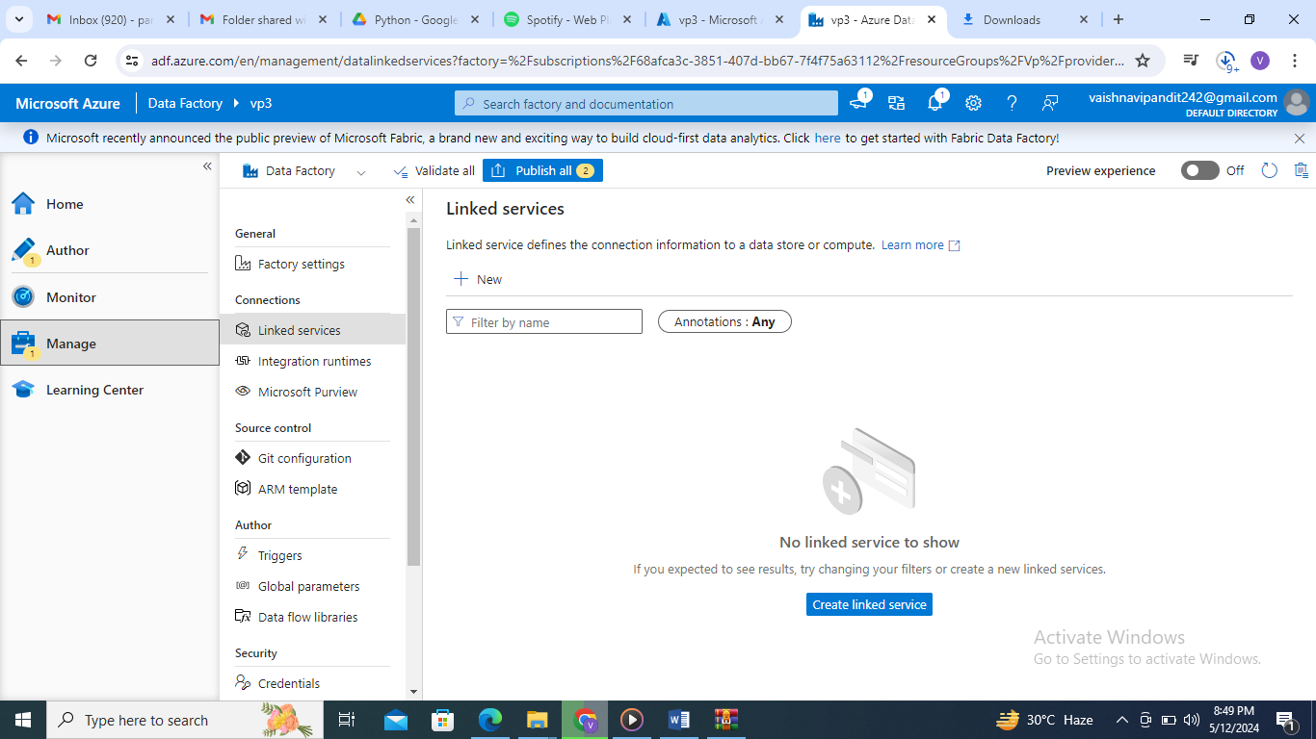

1. now create linked service and select azure data lake storage gen 2

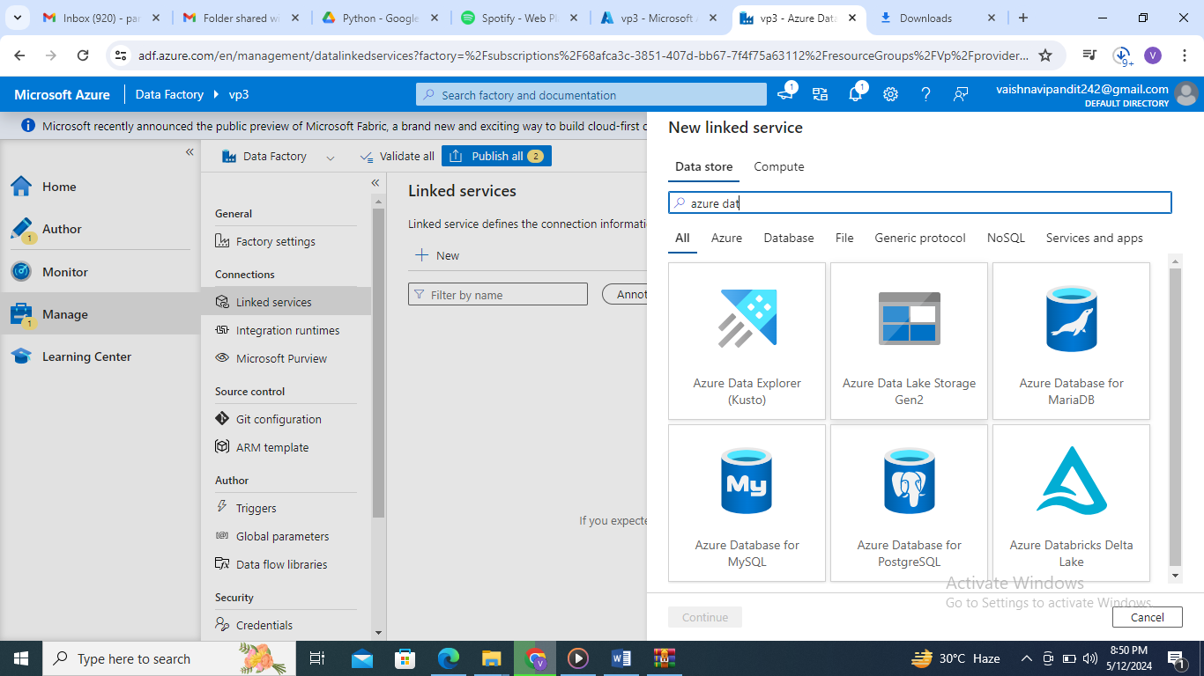

1. give name to linked service

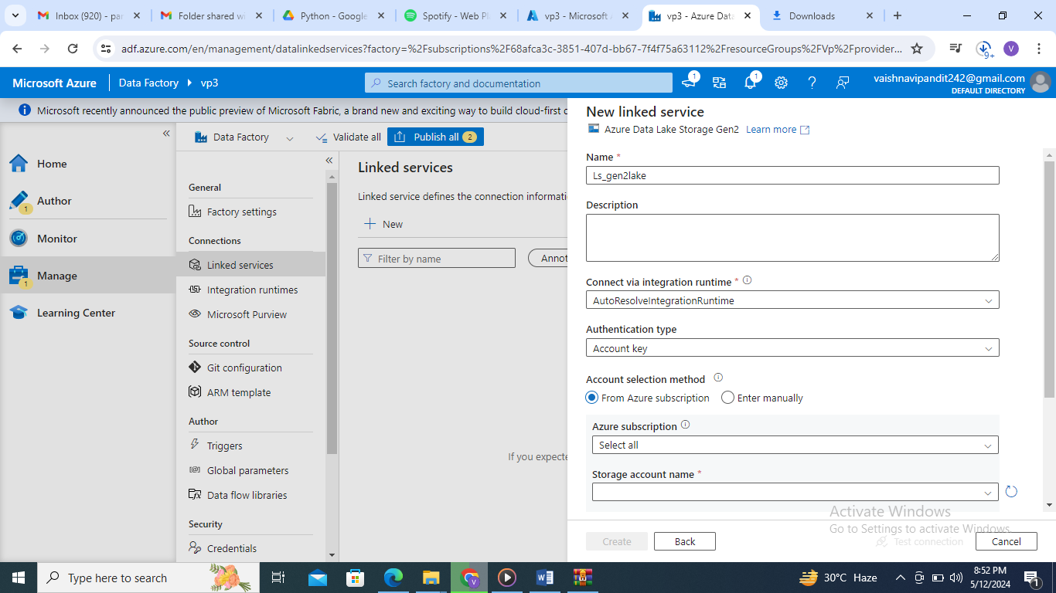

1. select subscription and data lake storge account to connect

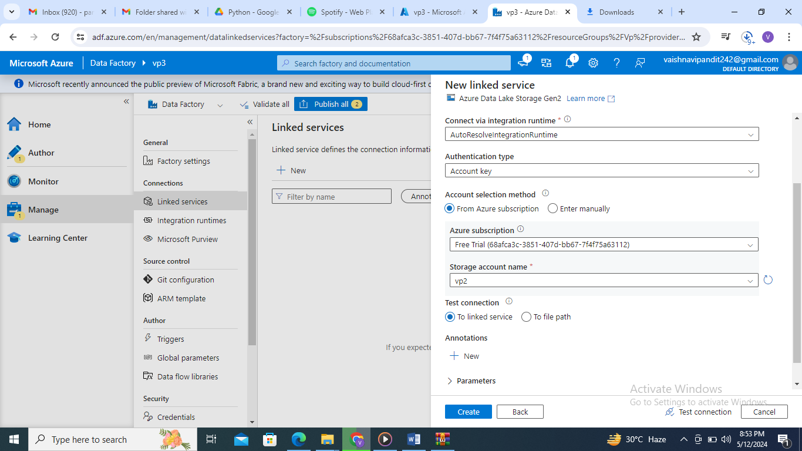

1. now create dataset to connect from adls to data location
2. go to author select dataset create dataset add name add linked service name ls_gen2lake and file path

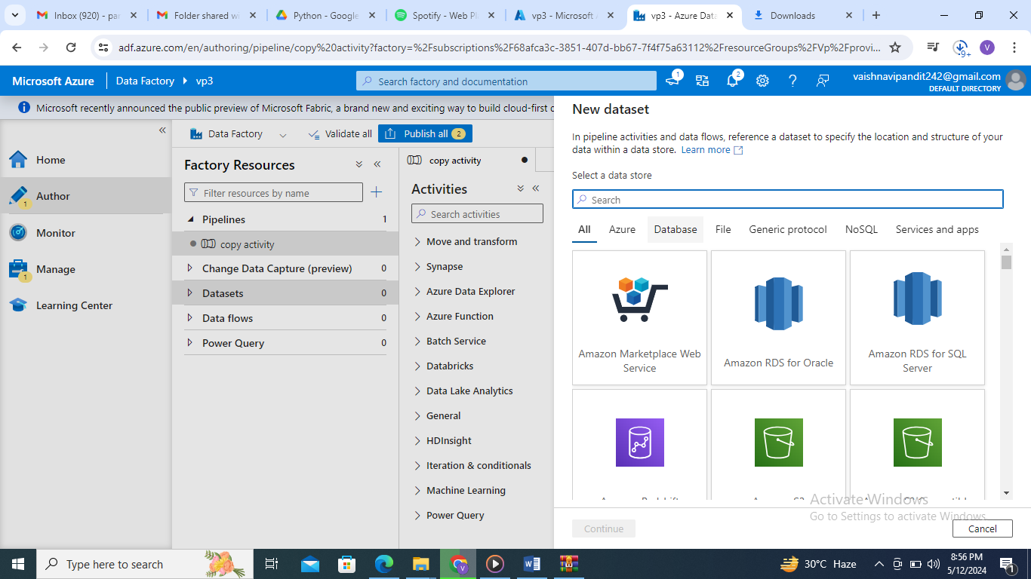

Select azure data lake storage

1. select format of data

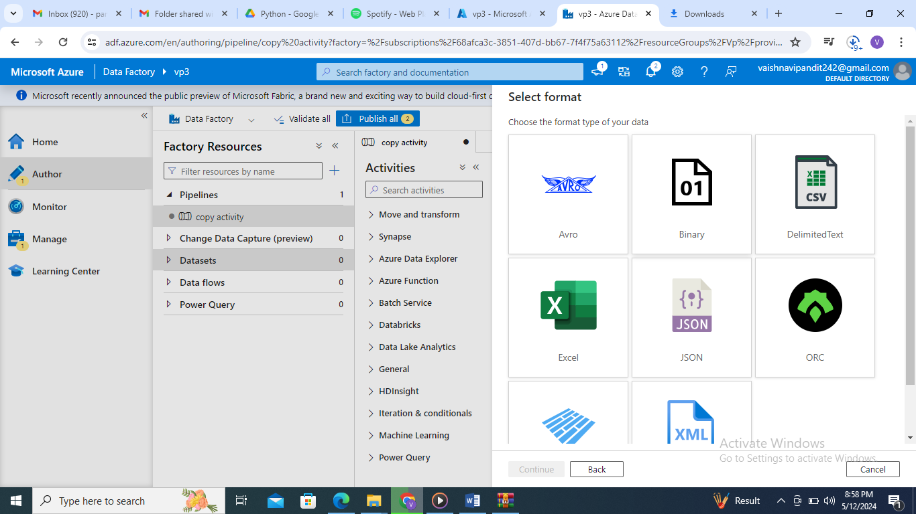

1. add name linked service name

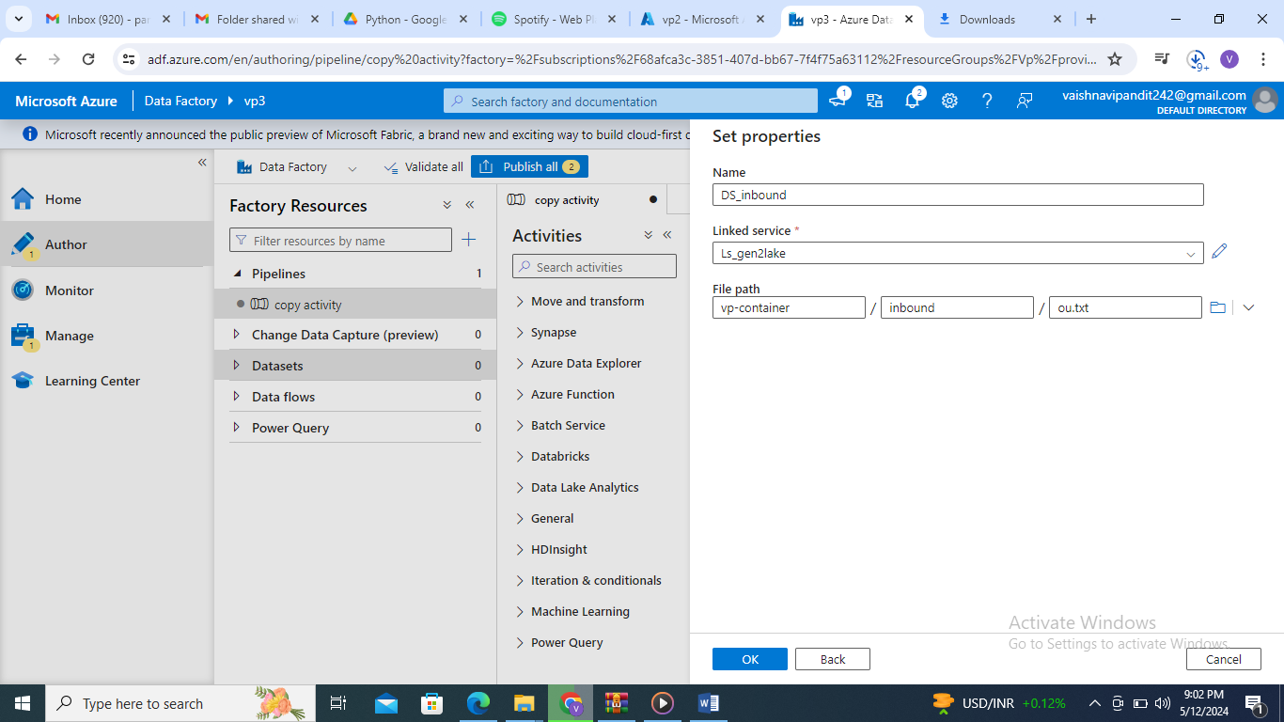

1. now create the outbound folder in adls if it is in same adls the use same linked service and create another dataset to connect to outbound folder
2. go to pipeline enter the source

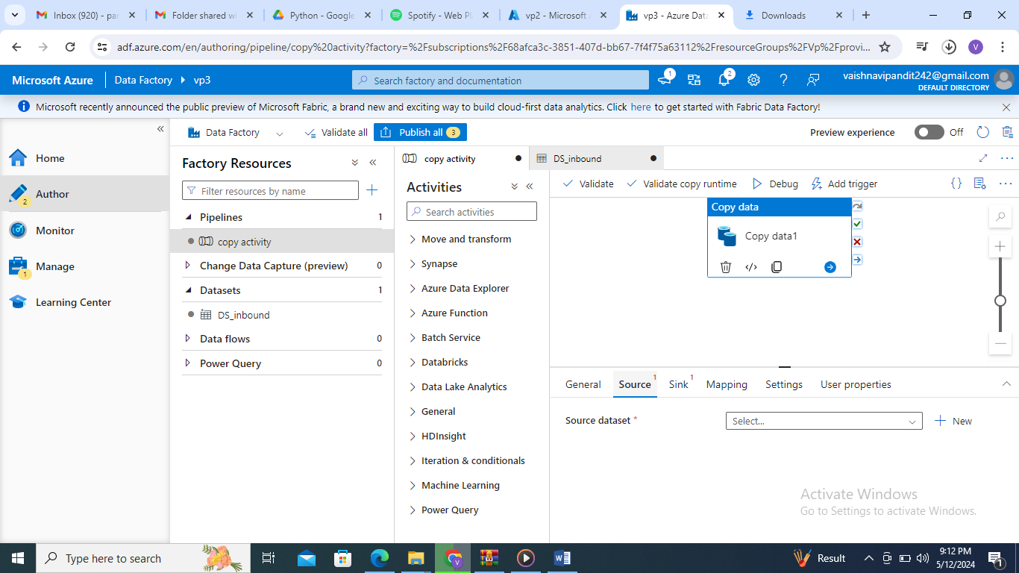

1. select source dataset

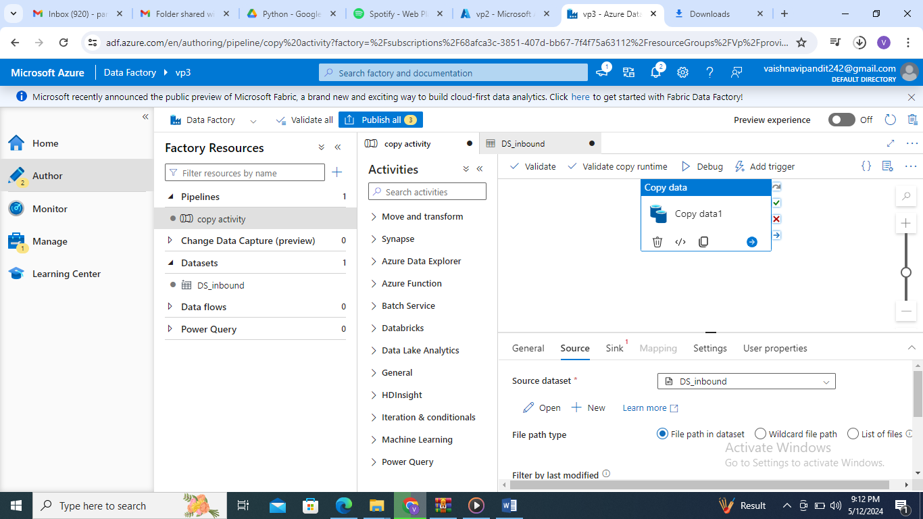

1. now add the dataset created for outbound folder in sink

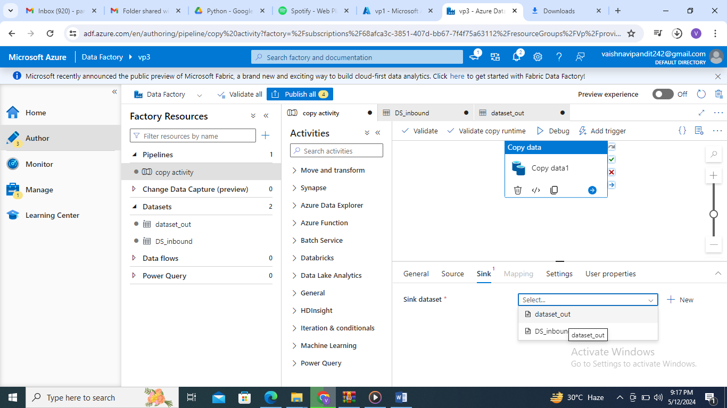

1. now publish and debug